7778 Vance Drive Arvada, CO 80003
P: 303-420-4422, F: 303-420-4681 E: welcome@indiantreeanimalhospital.com
www.indiantreeanimalhospital.com

Housetraining Puppies

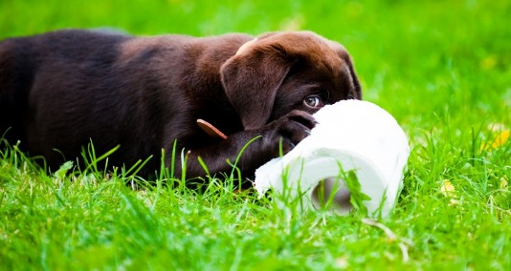
Housetraining puppies is easy, right? How hard could it be? Little puppies learn it all the time, right?

Sadly, that’s not the case.

Successful housetraining depends on aligning your handling with the dog’s instincts and helping the dog develop the habits you desire. It also depends on holing up your end of the bargain; giving the dog a good schedule of chances to eliminate.

The dog is never going to “understand” housetraining. Elimination means completely different things to humans as to dogs. A puppy who acts upset when you find a house training accident is not “feeling guilty” because the puppy “knows it’s wrong”. The puppy is showing submission to you, and possibly even fear of you. Nothing is being accomplished toward housetraining, and the puppy’s temperament may be suffering harm right then and there.

You can make a brilliant success of housetraining your puppy, whether you’ve ever done this task before or not, if you have the proper resources for the dog you have chosen. It is important to realize that “success in housetraining” is relative by the size and breed of the dog.

But while the dog is a puppy, you can do the right things to create the best possible chance of housetraining. There are windows of opportunity to develop these habits most easily in a puppy. If you fail to housetrain the puppy starting the minute the little paws step foot on your property, it puts the dog at a disadvantage. This disadvantage will grow and grow, and at some point it may become impossible for even an expert to housetrain the dog.

People will get rid of a dog over housetraining problems before they will get rid of one who bites people! Crazy as that is, it means failing to housetrain your puppy is profoundly unfair to the pup. You might be willing to live with an un-housetrained dog (but don’t bet on it-the mess will wear a person down as time passes)-but if for some reason you have to give the dog up to another home, no one else may be willing to live with that problem.

All of this means you need to do some things before bringing home a puppy:

- Study housetraining so that you have a plan in advance.

- Choose a puppy or dog who fits the facilities, time, and ability you have to offer.
- Bring the puppy home only at the time you are able to make housetraining a priority and see it all the way through. Most dogs are not capable of adequate bowel and bladder control for full housetraining until around 4 months of age. Small dogs frequently require longer. Complete housetraining is rarely accomplished in a weekend, though you can get a management program started in a long weekend or vacation.

- Wait to adopt a dog until you are able to provide suitable elimination opportunities.

Schedule

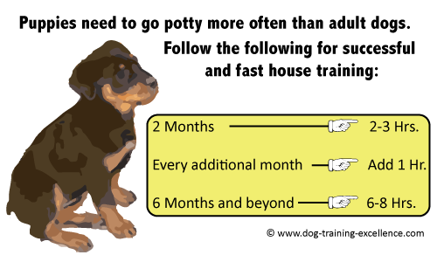
The first element of housetraining is a good schedule. The schedule means you commit to taking your puppy outside at certain, regular times. The puppy is then able to learn to count on those opportunities to relieve bowels and bladder.

You can’t explain to the puppy all the things you would like to explain about housetraining, nor can the puppy tell you exactly what is going on with that little body. In fact, the puppy doesn’t get enough warning at first to even make it outside. After all, that means getting your attention, persuading you to stop what you are doing to take the puppy out, waiting while you get ready and while you escort the puppy whatever distance it is to the outdoors and through however many doors until, finally, relief.

Besides the huge obstacles to the puppy having to be responsible for motivating you to provide access to the potty area, this method opens potential for behavior problems. Dogs who have to ask to go out to potty often ask to go out for other things. Dogs taught that you will only let them out when they bark may become problem barkers.

Dogs who develop a fear of going out (such as fear that you will stick the dog out there too long) may not tell you they want to go out-because they don’t! They need to, but they don’t want to. That’s a lot of worry to pile on a dog.

Fortunately, scheduling solves this problem. Some simple guidelines will get you started:

- Leave a puppy without access to a potty area during the day no longer than the number of hours equaling the pup’s age in months plus one. This means an 8-week puppy should not be left without a chance to potty for more than three hours. If you are gone 8 hours to work, a puppy this young should have more than one potty break.

- Don’t leave a dog of any age longer than 8 hours without access to a place to potty. It’s easy to see why dog walkers, pet sitters, and doggie day cares have plenty of clients.

- When you are at home and awake, give your dog a potty opportunity at least once per hour. The fact that your dog can hold it all night or 3 to 8 hours during the day at some point does NOT mean the dog can or should be asked to do so around the clock. On the contrary, the dog’s body has to catch up on waste elimination to compensate.

- Watch your dog or puppy for signs that once per hour is not often enough. Some small dogs and young puppies cannot hold it this long. If your pup was doing okay on that schedule and suddenly cannot make it, whether this is from behavior or medical reasons, this does need to be remedied promptly. Habits for life are being formed now, and you want everything aligned so those habits will be the right ones.

- Before you leave the house for work, take the pup out to potty at least twice. Take the dog out promptly when you return, even if you were gone a fairly short time. Also take the dog out before and after every time you are going to take the dog with you on a trip away from home. It’s important to establish this pattern so your dog can count on it; that helps the dog learn to relieve before your departure and to trust that you will be home in time, and you will take the dog out in time to make it until you get home.

- Associate a word or phrase with elimination in order to have a cue to give when you’re away from home or in some other situation where you need to tell the dog this time and place is acceptable for elimination. Use any words you like, such as “go potty” or “hurry up” or “better go now.”

- Take your puppy out to potty any time the dog “asks,” with body language indicating the need. Sometimes a diet change, treat, exercise, or other reason causes the scheduled time to be too long to wait.

Most humans and dogs naturally develop communication about this, but don’t count on it for housetraining. A schedule is far the better basic structure.

The dog dancing or bouncing, staring at you, resting the chin on your knee or pushing a nose at your hand can all be good signals that your dog needs to eliminate. To encourage a dog to use a particular signal, be sure to respond positively to that signal, in this case, by taking the dog outside. Some people like a bell at the door as well.

- If you think your dog has developed a habit of asking to go out more often than needed, you can try extending the time just a little. But truthfully, letting the dog out a few extra times is a lot less work than cleaning up a mess because you didn’t “believe” what the dog was telling you! Every accident takes away from the habit you are trying to build and puts the wrong scent into the house. It’s worth the extra effort to help your dog avoid accidents.

- As your puppy matures, you may be able to reduce the schedule of outings. Keep in mind, though, that any change in a dog’s physical state can cause the dog to need to eliminate urgently or more often than normal. Aging dogs often experience this shift. Do not consider this a “behavior problem.” It’s a physical need that we have a responsibility to meet.

Crate Training

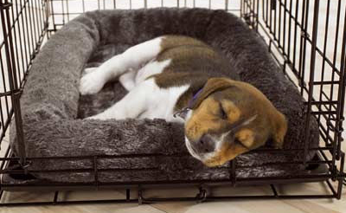
People mean different things by the term “crate training.” Used properly, crate time can help your puppy learn it’s safe to be alone for reasonable periods of time and that confinement is nothing to fear. It can also keep your puppy from carrying out undesired behaviors and making those habits stronger when you absolutely cannot supervise your puppy.

But when you can supervise your puppy, the puppy needs to be out of the crate and under your watchful eyes. Puppies have dozens of things to learn, and they need to bond to you. They also need mental and physical exercise.

It’s entirely feasible to raise a puppy successfully with no crate at all, but it is highly desirable to teach a young puppy to rest calmly in a crate, as insurance for potential later life situations, including the destructive chewing stage that comes with the second set of teeth. Other confinement areas can work for this training, but the veterinary hospital, grooming shop, travel, medical restricted activity, and emergency evacuation may call for crate confinement. When a crate is necessary, you don’t want that to add stress to what may already be a stressful situation.

Get a crate for your puppy and condition the puppy to be happy inside the crate. Occasionally you’ll hear the advice, usually from well-intentioned people, to keep your puppy in the crate full-time except for trips out to potty. Don’t do this. It will cause more problems than it could ever solve.

If your puppy is having accidents in the crate, there is likely a reason. One is that you are asking the puppy to hold it longer than the puppy’s body is capable. You will have to change the schedule; otherwise, your puppy’s instincts to keep the bed area clean will be damaged, and you’ll have a bigger job to housetrain.

Another potential cause of a puppy soiling the crate is that the puppy is not well. Puppies are fragile, and their immune systems quite vulnerable. Take a puppy to the veterinarian within 24 to 48 hours of adoption, and also take the puppy to the veterinarian immediately at any sign of illness, including diarrhea. This is especially true of small-breed puppies. They have little physical reserve and need quick aid.

Also take your puppy for all the recommended care, including the puppy vaccination series. The vaccination interval has changed for adult dogs, but the puppy interval has not. Puppies need this protection; their little lives depend on it. And the puppy needs veterinary checks. You need your veterinarian’s expertise to watch over your little one.

Anytime your puppy is soiling the crate, get the puppy out of the crate for a while and use a different confinement method. Two good options are a portable exercise pen or a small room with a baby gate across the door.
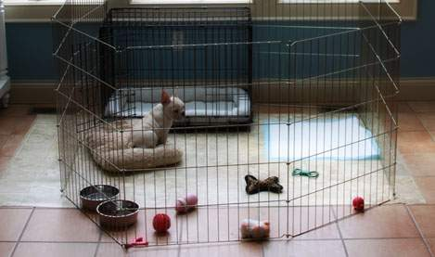
You can buy pens of various heights and tops for them. If the dog jumps over a baby gate, you can stack a second gate above that one. Do not use a closed door to confine a puppy. That leads to more noise, as well as to some puppies developing habits such as scratching up the closed door or digging up the flooring at the base of the door! The puppy needs to be able to see out of the confinement area, and you need to be able to peek in at the puppy without awakening the little tyke.

Have water available to your pup all the time. You may read advice to limit water during housetraining, but this can backfire and can be a health risk. Dogs need water even more critically than humans do, and they cannot ask for it. If you restrict water, the dog may tank up on it when it is available and actually make housetraining harder. The health risks are the biggest concern.

At the end of the enclosure, put the dog’s water and toys. If you can provide bedding without the dog eating it or eliminating on it, put the bedding there too. If you feed in the confinement enclosure, feed at that same end.
Eventually you may be able to use a crate again. You might test it about 2 weeks after the pup stops all elimination in the confinement area. If the pup eliminates in the crate again, discontinue its use for another long period before another trial.

Always use a confinement area other than a crate if there is any doubt about the length of time you’re leaving your dog without a chance to get out to potty. This takes a lot of stress off your dog and could make the difference between developing separation anxiety or not. That is not a problem you want with your dog!

If for some reason you are not training your puppy to eliminate outdoors, confinement to a small area with the litter box or whatever you are going to use is gradually extended to larger areas. Realize that it is not the dog’s fault if there are occasional indoor accidents. This is just never going to make sense to the dog. Do not punish it! In the event of accidents, reduce the size of the confinement area again.

Basics and Tips

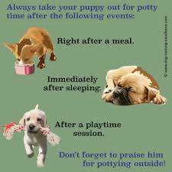
Decide where you want your puppy to eliminate at your home. An outdoor fenced area that does not expose your puppy to other people’s dogs is ideal. If you have this, you can housetrain our puppy straight to the outdoors-with perhaps some indoor paper use in a confinement area if you have to leave the pup too long during your work day or the puppy can’t make it through the night.

If you don’t have a yard, you may be able to rig up a box of grass sod or other arrangement on a patio. Like teaching the puppy to use the outdoors early in life, this creates a clear concept of the indoors as the “den area,” and the outdoors as the appropriate place to eliminate. This is the fastest, clearest, and most enduring route to housetraining.

If you do not have safe outdoor facilities to use prior to full vaccination, you may have to wait to switch to outdoor housetraining until around 16 weeks, or whatever time your veterinarian gives the go-ahead. It is important that your puppy have SOME experience eliminating on grass as early in life as possible. If your breeder has done this, you’re covered. If not, maybe you can find some safe grass for a few outings.

Puppies need more frequent meals than adult dogs. Find out what food and meal schedule the puppy has been on in order to have some of that food on hand before the puppy arrives. On the first veterinary visit, ask about feeding and make any recommended changes.

Only on your veterinarian’s instructions should you ever suddenly change a puppy’s food. Dogs have to have time to develop the right friendly bacteria in their intestines before they can digest a new food. A puppy new to your home is under stress, and the intestines are immature. You need to make these transitions gradual unless there is a good reason to do otherwise. A sudden food change can cause serious diarrhea and/or vomiting.

Don’t let anyone overfeed or feed junk. Unless your veterinarian recommends otherwise, give your puppy scheduled meals rather than leaving food out all the time; this has behavior benefits as well as health benefits. Follow your veterinarian’s instructions because different situations call for different feeding.

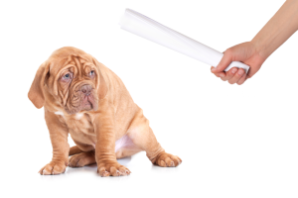
Never punish your puppy over housetraining. It does not work, and it creates more serious problems than housetraining accidents. These include making the dog defensive about other things, making the dog hide from you to eliminate, causing the dog to lose trust in you, and even creating an aggressive personality. Punishment doesn’t solve the housetraining accidents anyway, so it’s just a problem all the way around.

When you first arrive home with your puppy, take the puppy to the place you have chosen for elimination. If that is a certain small part of your yard, have that area marked off with some sort of clear physical boundaries. A decorative fence, landscape timbers or flowerbed edging will do.

Each time you walk outdoors with your puppy, say “Let’s go outside!” You can also ask your puppy “Do you want to go outside?” Associate the word “outside” with going out the door. The “go potty” phrase is not for this. “Go potty” means its okay for the puppy to eliminate right here, right now. Don’t confuse the two cues. You don’t want the puppy to think you mean to potty inside on the floor when you say “outside.”

In the right place, say “go potty” phrase, and wait for the puppy to eliminate. Praise softly, and try to reward in a way this puppy would like-as you get to know the puppy, you’ll develop more options for rewards. These could include praise, petting, treats, a game, more time to play outside, going back inside immediately, or going for a walk. Be careful with the timing of your reward to make sure the pup has completely finished eliminating. Some puppies need to do it twice before they are really done. Many puppies need to run round a little bit-as do many adult dogs.

Don’t leave the puppy outside alone. You need to know when the puppy eliminates in order to reward at the right time and to adjust the schedule, and the puppy needs to be free from worry about being stuck out there alone. Some people find it helps to keep a log of when the dog potties. Certainly you want a written record of any time the puppy has diarrhea, because if it continues, the veterinarian will need this information.

If you “catch the dog in the act” of having an accident, the rule about no punishment still holds!!! Hustle the puppy outside quickly, with nor more than a “no-outside” spoken in a normal, calm tone of voice. Once out there, say your “go potty” cue and wait. If the dog does it, that is a huge success, and you want to give great praise and reward. If you weren’t fast enough, still be upbeat with the dog outside. Just being there needs to make your dog feel your approval.

Dogs do not understand housetraining because to their instincts the urine and feces is not offensive, dirty, insulting, or shocking. If your dog is not too small and your house is not too big, the dog can often develop a sense of the house as the “den” area to keep clean. Otherwise, you’ll need to confine the dog to whatever area the dog can manage.

Housetraining does not automatically transfer to someone else’s house, so keep your dog on leash, in a crate, or in a portable exercise pen when visiting. Males in particular will feel duty bound to mark a new place. Take this responsibility off your boy dog.

You don’t need a large yard for housetraining, but you do need to pick up feces frequently, preferably every day. If you’re trying to cultivate nice plants in the area or if it doesn’t get much sun, you’ll also need to water frequently to dilute the urine.

Cleaning

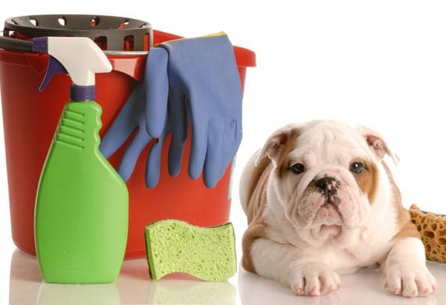
Not knowing the right products to use for cleaning presents a major obstacle to housetraining. There is no reason to have a ruined carpet or reeking home while housetraining a dog. If you do have odor, the puppy’s instincts will be overwhelmed by it and you will get more accidents-the pup can’t help it.

With the wrong products, owners may not be able to smell the odor (temporarily-eventually it comes back), but dogs can. One dog in the house having accidents that are not properly treated leads to other dogs doing it-including dogs who move there later. The scent is a signpost to the dog’s instinct that this is the bathroom.

Once the spot has begun to dry, the only reliable product to use is a bacterial enzyme odor eliminator product. These come in various brands. The product must penetrate as deeply as the urine did. In many cases you will need to apply it more than once. You may also need to keep it active awhile by covering it with warm, moist towels. In severe cases, you may need a professional cleaning service.

This is one more reason to watch your puppy at all times the pup is not in the safe confinement area. When you see an accident happen or find it immediately after it has happened, you can use undiluted clear vinegar instead of the more expensive enzyme product as it actually aids training.

Apply the vinegar (or any other cleaning you do) without commenting to the dog. Vinegar gives a scent message to the dog that discourages the dog from using that spot again soon. It’s a big boost to housetraining.

Remember, no punishment. Just put the vinegar on the spot-liberally-and let it dry. It doesn’t matter whether the dog sees you do it or not. You can hasten the drying process in carpet by placing layers of newspaper or thick toweling over it and stepping on that. It will pull liquid out of the carpet and pad.

Don’t use ammonia for cleaning around a puppy or dog. It smells like urine, and can lure the dog to eliminate there.

Teamwork

Housetraining is probably the first major goal that you and your puppy will achieve together. At various times in your dog’s life will come times the body needs special care. Housetraining is one way the two of you prepare for that. Sick dogs, injured dogs and aging dogs often have special requirements you don’t expect.

Housetraining the puppy is when you learn to aid your dog instead of losing patience and throwing a tantrum! It’s also when your puppy learns to trust you and to look to you for help with physical needs. It’s an important part of learning to live together, so give it your best. Your dog will meet you at least halfway-dogs always do.

Ask our staff for more assistance with this!

